*Show vs. Tell*

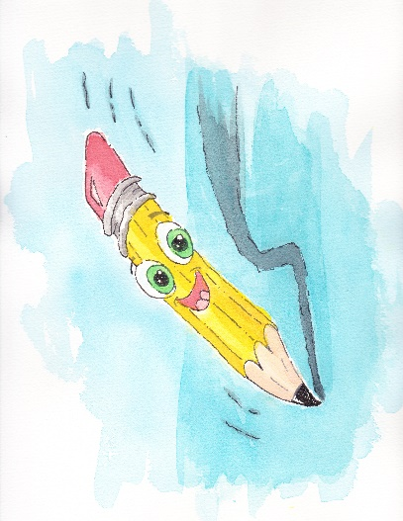

If there was one piece of writing feedback I disliked most as a new writer, it certainly was “Show, don’t tell.” And, believe me, I got this feedback often. Each writer likely stumbles over when and how often and at what pace showing is required.

Initially, I had no idea what it meant. Self-help writing blogs often toss this phrase around without examples. I even had a critique done on my writing once, and the person critiquing said this phrase several times but offered no help on what showing actually meant. Finally, I stumbled upon a quote that changed my outlook on writing forever.

*“Don’t tell me the moon is shining; show me the glint of light on broken glass.” -Anton Chekhov*

It clicked for me. I finally got it. At least, it was enough to where I knew what the heck those people were talking about. Nonetheless, a supply of examples helps writers of all levels of experience.

*“Show the readers everything; tell them nothing.” -Ernest Hemingway*

It’s not possible to write an entire book without “telling” something. You have to “tell” the reader *something* eventually. What I hope everyone will do, is to pick off at least the obvious instances to show rather than tell.

Virtually every human emotion could be shown. Observe your friends when they talk. You don’t need to hear your friend’s thoughts to know when they are feeling certain emotions. True, you have the visual cues that you don’t have in a book, but you can describe the visual cues in writing, which in most cases is all you need. Increasing the amount of “showing” in your books could mean the difference between a good book and a great book.Bottom of Form

Eavesdrop on strangers. This’ll guide you in character development, as well as giving the writer solid material to ‘show’ three-dimensional behavior. How is the villain’s self-absorption manifested? Use dialogue. Make the reader connect the dots and cringe with anger after reading about your nasty villain.

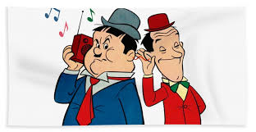

Think about why showing rather than telling is taught worldwide. Why is it so important and popular these days? Literary trends change over time, although much more slowly than, say, fashion trends. These days, the trend in commercial fiction is concise, lean writing without a lot of overly-descriptive “purple prose.” Prologues are somewhat out of fashion for certain genres. Third person limited and first-person are by far the most popular these days.

Showing opens the door for the writer to ‘show-off’ true creative writing talent. But, I think, to be skillful, the writer is required to do so in thoughtful and measured amounts. My personal pet peeve is reading skillful descriptive writing, but the plot fails to move forward.

*“An overturned tricycle in the gutter of an abandoned neighborhood can stand for everything.” -Steven King*

I believe that we show rather than tell because the modern reader is pretty smart. Fiction, in some form, has been around for thousands of years. Readers have come to expect certain things when they read stories. They may not be able to name literary devices, but they are intuitive nonetheless.

*“Good writing is supposed to evoke sensation in the reader–not the fact that it is raining, but the feeling of being rained upon.” -E.I. Doctorow*

What fun is a crossword puzzle that gives you all the answers up front? It’s much more interesting, and more challenging, to be hinted toward the answers. Essentially, when you “show” in your novel, you are hinting at the answers. You don’t have to come out and say the whole thing; you can give the reader several pieces, and the reader can apply the final piece. It’s an interesting dynamic when you think about it, and it’s much more gratifying to the reader.

*“The secret of being boring is to say everything.” -Voltaire*

 The same principle applies to comedy. If you provide all the information upfront, it’s not funny. But when you give the audience every piece but one (with the right timing), the joke is hilarious. The audience’s mind supplies the final tiny piece of information.

*“A writer should seize upon small details, arranging them so that the reader will see an image in his mind after he closes his eyes.” -Anton Chekhov*

So! How about some examples?

* **Telling:** Tiffany felt afraid. He pounded on the door, demanding to be let in.
* **Showing:** Tiffany gripped the sheets in bunches between her cold fingers. Her forehead was slick with sweat. The door rattled again and again against its weak hinges. She didn’t imagine it would be long before he got in.
* With this example, it shows physical signs that Tiffany is afraid, rather than telling the reader out-right. The reader can easily surmise that she is afraid by those physical clues and the context.

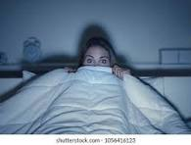

* **Telling:**The crowd looked angry. He wouldn’t be surprised if they revolted. The guards did what they could to keep the peace.
* **Showing:**The crowd boiled like a simmering cauldron. When the guards weren’t looking, some of the people threw apple cores, aimed at the well-polished helmets. Yells and curses cut through the air. The captain stepped forward with his hands spread out.
* In this example, you can tell the crowd is upset because of the simile and the fact that they are yelling and throwing things. Saying they are upset doesn’t really move the plot forward, but the crowd throwing apples at the guards does, while at the same time showing their anger.



* **Telling:**Luke drew his sword. He knew this would be the fight of his life.
* **Showing:**Luke drew his sword. He eyed the graceful movements of the man standing in front of him. His opponent held his sword easily, as one would after a lifetime of applying it. Luke willed his hands to stay dry.
* It’s fairly clear that Luke’s hands are threatening to sweat because he is nervous to fight his opponent, who looks intimidating by his battle stance. Reading that indication is likely enough to signal to the reader that he may be in a tough fight without needing to tell the reader as such.

* **Telling:**“You have nothing to worry about,” Susie said. It was clear she was lying.
* **Showing:**Susie shifted her weight, never bringing her eyes up fully to meet mine. When she did speak, she interrupted the sentence by biting her lip. “You have nothing to worry about.”
* Although the “tell” in this example isn’t terrible, you can use physical cues to show that Susie is not confident about what she’s saying. Maybe you want to shed doubt on Susie, but you don’t want to out-right tell the reader that she’s lying, for reasons of mystery. It may not be a simple “which is better,” but it might be a question of how much you want to reveal and when. Showing hints is imperative in a mystery subplot.

I hope this tickles your writing brain when sitting to write your next article, novella or novel. Happy writing!

